IT PAT 2020

Josh pearson 12d

Teacher: mrs dukhanti

2020

Table of Contents

Task Definition 2

User Requirements 2

User 1: Employee 2

User 2: Admin 2

Flow Diagram 3

Data Structures 4

Database Design 4

Table 1: Clients 4

Table 2: Hotels 4

Relationships 4

Class Description and Diagram 4

Text File and Array 4

GUI Design 4

IPO 5

Input Interfaces 5

Input validation 5

Data Processing 5

Data Output 5

# Task Definition

Tourism is a large source of income for South Africa. There are therefore a large number of different hotels and airports for tourists to choose from. Trying to choose between the best tourist spots and hotels can take a long time and can lead to regrets when the chosen hotel or B&B isn’t as good as the tourist thought from seeing it on the internet. For this reason, there is a need for a program that can be used by travel planning companies to help customers plan where they would like to stay during their trip. I will be making a program where people can choose the airport where they will arrive that will also help them decide by showing them hotels near them and a list of popular tourist attractions.

I would like to have a link to each attraction/hotel’s website if there is one so that the tourist can see more information on it. After choosing a hotel, number of people, an arrival date and a departure date, the number of days they will be staying will be calculated and a total price will be shown for the stay at the hotel/B&B. There will be a button that opens a new screen that shows the attractions near the place the tourists will be staying.

# User Requirements

User 1: Employee

The employee at the travel planning company who will work with the customer to plan the trip to South Africa. The employee is responsible for guiding the customer through the selection and confirmation of their choices. The employees will not be able to change information in the Hotels table but can only change information in the Clients table.

User 2: Admin

The admin will be the person who edits information on hotels like prices, information on the attractions in the area and information on restaurants in the area. The admin is only needed to fix or change information. The admin is not able to change information in the Clients table, but only the information in the Hotels table.

# Flow Diagram

# Data Structures

## Database Design

### Table 1: tblClients

|  |  |  |
| --- | --- | --- |
| Field name | Field type and size | Example |
| RefCode (PK) | Short Text – 6 | JP0123 |
| Name | Short Text – 25 | Michelle, Josh, etc. |
| Surname | Short Text – 25 | Lindique, Pearson, etc. |
| IDNumber | Short Text – 13 | 0211045178087 |
| Hotel | Short Text – 40 | Protea Hotel, etc. |
| ArrivalDate | Date/Time - YYYY/MM/DD | 2020/02/04 |
| DepartureDate | Date/Time - YYYY/MM/DD | 2020/02/10 |
| DaysStaying | Number | 7 |
| NumberOfPeople | Number | 2, 1, etc. |

### Table 2: tblHotels

|  |  |  |
| --- | --- | --- |
| Field name | Field type and size | Example |
| HotelName (PK) | Short Text – 40 | Taj Cape Town, Protea Hotel Johannesburg, etc. |
| Province | Short Text – 40 | Cape Town, Johannesburg, Pretoria, Durban, etc. |
| Rating | Number | Rating out of 10 |
| DistanceFromCenter | Number | Distance from the city center |
| 1 Sleeper | Yes/No | If the hotel has a room that sleeps 1 person |
| 2 Sleeper | Yes/No | If the hotel has a room that sleeps 2 people |
| 3 Sleeper | Yes/No | If the hotel has a room that sleeps 3 people |
| 4 Sleeper | Yes/No | If the hotel has a room that sleeps 4 people |
| PricePerNight | Currency - In Rand | R 1580.00, R1795.00, etc. |

## Relationships

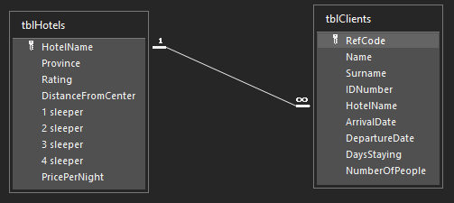

## Class Description and Diagram

clsClient: every new client’s information will be instantiated in an object and will then populate the record in tblClients in the HotelDatabase.

## 

## Text Files and Arrays

* tPasswords (from Passwords.txt): This textfile will hold the usernames and passwords of the employee(s) and admin(s). It will be accessed in the login in screen (screen 1) and if the user inserts the correct details, options will become visible for them to choose from. The username and password will be separated by a “#” and the word “ADMIN” and “EMPLOYEE” will be used to identify the details in the lines.
* tAttractions (from FiveAttractions.txt): This textfile will contain a list of 5 popular attractions in each province. Each attraction will be separated by a “#” and the province names will be used to identify which attractions belong where.
* tRestaurants (from FiveRestaurants.txt): This textfile will contain a list of 5 popular restaurants in each province. Each restaurant will be separated by a “#” and the province names will be used to identify which restaurants belong where.
* arrHotels: an array will be created by reading the names of the hotels and copying them to the array. The array will then be used to populate comboboxes where the user can select a hotel

## Other Data Structures/Advanced Programming Constructs

In the login screen, there will be in image object on the form and a gif will be assigned to it and animated. The image will be animated using the line “(imgPlane.Picture.Graphic as TGIFImage).Animate:=True;” when the form activates.

GUI Design (3)

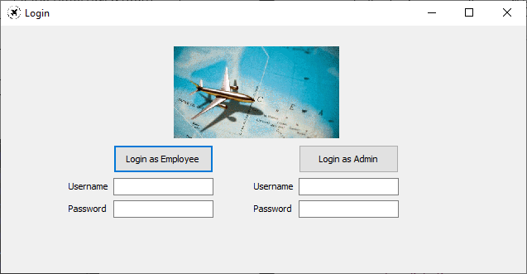

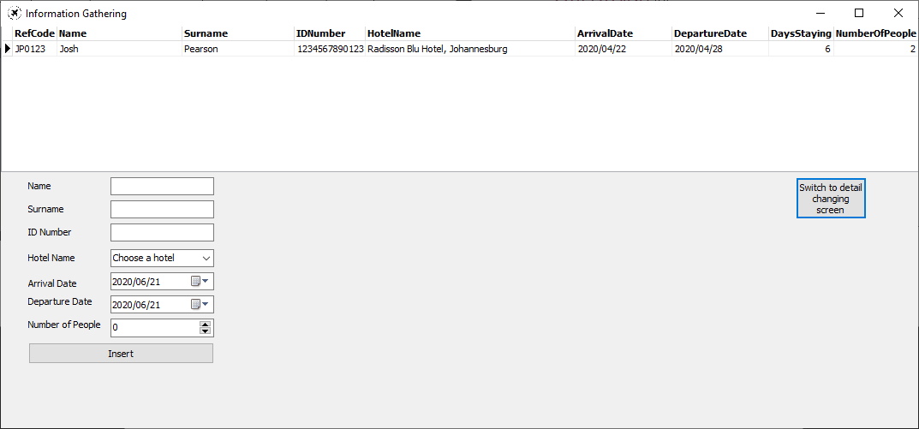

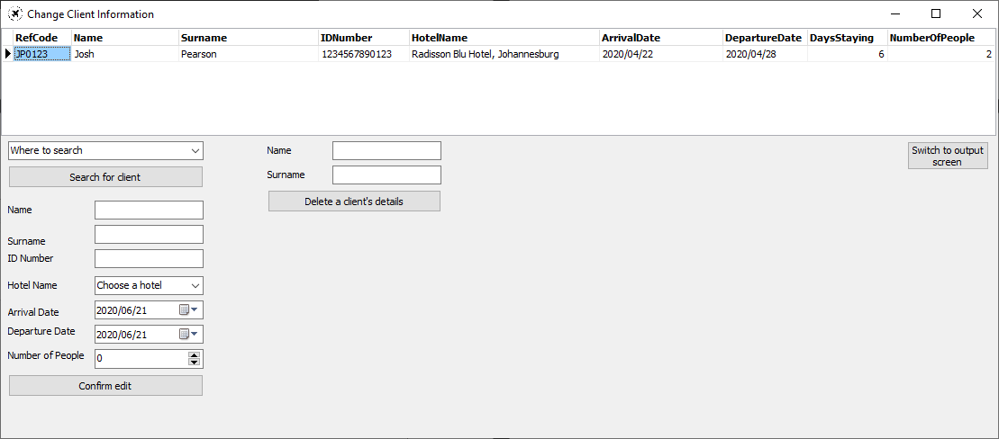

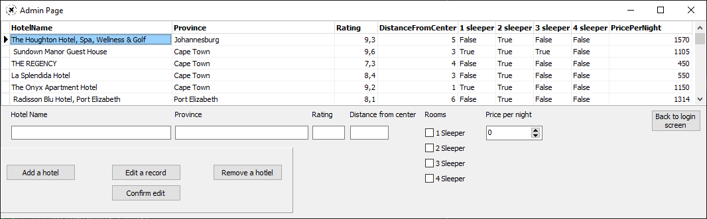

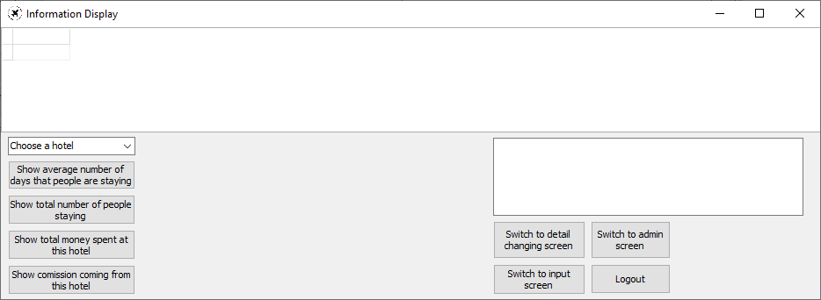

IPO

Input Interfaces (3)

## Input validation

1. Login Screen: Checking the username and password: There will be an if else statement that will check whether the user has entered their username and password and then check if the uppercase of the username and surname match the username and password in the textfile. If the inputs are blank, a message will be shown to inform the user and if the inputs are incorrect, the edits will be cleared, and a message will inform the user that their inputs were wrong.
2. Inserting a hotel name: the array arrHotels will populate each checkbox where the user will choose from a list of hotels. If the user does not choose a hotel, a message will be shown in order to tell them to choose a hotel.

Data Processing (8 processes, 4 in detail)

1. Login screen: retrieving details from the textfile: The textfile will be assigned to tFile in the FormActivate procedure and a while loop will run while the file hasn’t reached the end and inside of the loop, an if else statement will be used to assign the line to either sAdmin or sEmployee. The if statement will check whether the first word of the line is “ADMIN” or “EMPLOYEE” and assign the entire line to the respective variable.

## Data Output

1. The user will be able to find out the average number of days that people are staying at certain hotels.
2. The user will be able to find out the total number of people staying at a certain hotel.
3. The user will be able to find out the total amount of money that a certain hotel will make from the bookings.
4. The company gets a 10% commission of the amount that the hotels get, there will be a button to show the total amount that should come from a certain hotel.